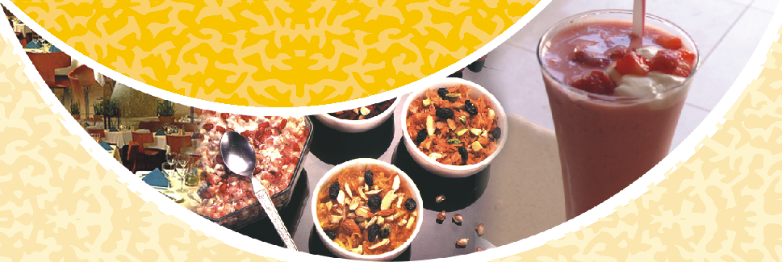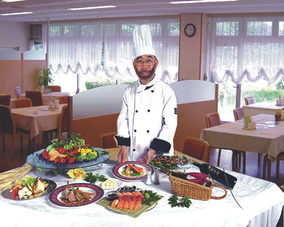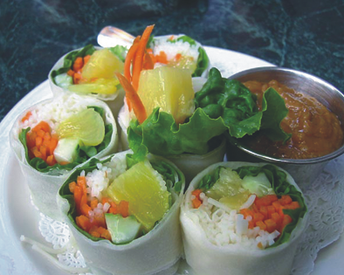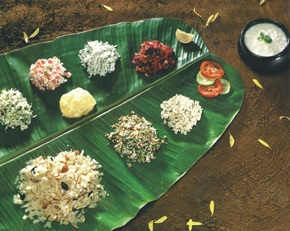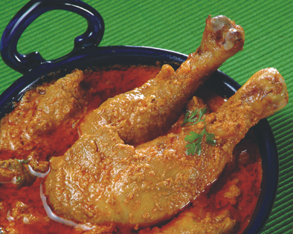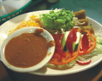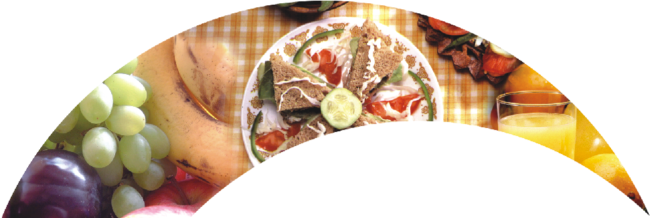

**T h e**

Putting the world

in your reach

**RESTAURANT**

WELCOME TO THE RESTAURENT

**O U R P E O P L E**

**O U R R E C I P E**

You can enjoy a first - class Restaurant Wine Flight and the restaurant's signature Caesar Salad Chocolate Lava Cake, a dessert soufflé of volcanic proportions served warm at your table.States.

Infuses them with Restaurant's own unique friendly and inviting atmosphere. For fine dining in a casual & relaxed atmosphere. Restaurant currently boasts more than 25 locations across the Continental United States.

The Pub is a place where you can enjoy a hearty meal or a simple snack, where good honest food is crafted in a

classically modern British and European style. The freshly

brewed beer is eminently drinkable and the selection of single malt whisky is extraordinary. You can relax in comfortable surroundings with thoughtful, friendly service...!

Check our website http://www.ourwebsite.com for weekly food events and daily special menu list. Get delicious food recipes daily.

Although hotel has long been serious about good food, it recently added an exciting array of fresh fish and seafood to its menu. Seafood lovers can now savor a Crab, Avocado & Mango stack appetizer before diving into delectable dishes such as Dynamite Mahi-Mahi or Snapper Hemingway. To top it off there's hotel's signature Chocolate Lava Cake, a dessert soufflé of volcanic proportions, served warm at your table.

Welcome to sunrise hotel Our Contries tradition for 40 years. Since first opening its doors in 1961,hotel has been synonymous with great food and a casual, relaxed atmosphere. hotels currently boasts more than 25 locations across the Continental United States. Whether perched on the water's edge in Florida or along the beautiful California coastlines, every Restaurant location raws on the local region's natural features - from the setting and architecture to the style and attitude - and infuses them with hotel's own unique friendly and inviting atmosphere.

**PUB & WINE SECTION**

**Weekly events**

**O U R F O O D & M E N U**