[](http://www.office-lernen.com)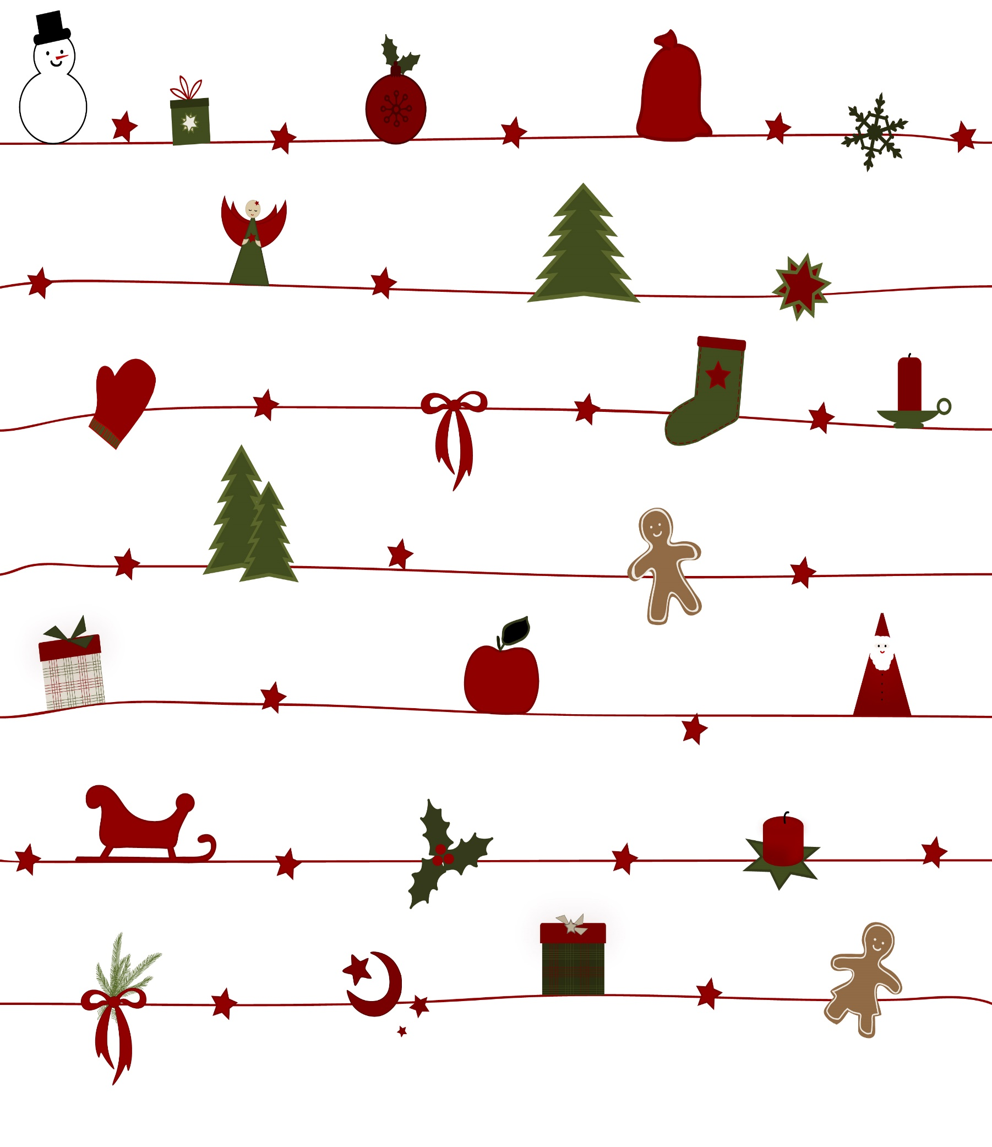

8

*August*

9

*September*

10

*Oktober*

11

*November*

12

*Dezember*

1

*Januar*

2

*Februar*

3

*März*

4

*April*

5

*Mai*

6

*Juni*

7

*Juli*

|  |  |  |  |  |  |  |
| --- | --- | --- | --- | --- | --- | --- |
| **M** | **D** | **M** | **D** | **F** | **S** | **S** |
|  | 1 | 2 | 3 | 4 | **5** | **6** |
| 7 | 8 | 9 | 10 | 11 | **12** | **13** |
| 14 | 15 | 16 | 17 | 18 | **19** | **20** |
| 21 | 22 | 23 | 24 | 25 | **26** | **27** |
| 28 | 29 | 30 | 31 |  |  |  |
|  |  |  |  |  |  |  |

|  |  |  |  |  |  |  |  |
| --- | --- | --- | --- | --- | --- | --- | --- |
| **M** | **D** | **M** | **D** | **F** | **S** | **S** | **S** |
|  |  |  |  | 1 | **2** | **3** | 41 |
| 4 | 5 | 6 | 7 | 8 | **9** | **10** | 8 |
| 11 | 12 | 13 | 14 | 15 | **16** | **17** | 15 |
| 18 | 19 | 20 | 21 | 22 | **23** | **24** | 22 |
| 25 | 26 | 27 | 28 | 29 | **30** |  | 1 |
|  |  |  |  |  |  |  | 8 |

|  |  |  |  |  |  |  |
| --- | --- | --- | --- | --- | --- | --- |
| **M** | **D** | **M** | **D** | **F** | **S** | **S** |
|  |  |  |  |  |  | **1** |
| 2 | 3 | 4 | 5 | 6 | **7** | **8** |
| 9 | 10 | 11 | 12 | 13 | **14** | **15** |
| 16 | 17 | 18 | 19 | 20 | **21** | **22** |
| 23 | 24 | 25 | 26 | 27 | **28** | **29** |
| 30 | 31 |  |  |  |  |  |

|  |  |  |  |  |  |  |
| --- | --- | --- | --- | --- | --- | --- |
| **M** | **D** | **M** | **D** | **F** | **S** | **S** |
|  |  | 1 | 2 | 3 | **4** | **5** |
| 6 | 7 | 8 | 9 | 10 | **11** | **12** |
| 13 | 14 | 15 | 16 | 17 | **18** | **19** |
| 20 | 21 | 22 | 23 | 24 | **25** | **26** |
| 27 | 28 | 29 | 30 |  |  |  |
|  |  |  |  |  |  |  |

|  |  |  |  |  |  |  |
| --- | --- | --- | --- | --- | --- | --- |
| **M** | **D** | **M** | **D** | **F** | **S** | **S** |
|  |  |  |  | 1 | **2** | **3** |
| 4 | 5 | 6 | 7 | 8 | **9** | **10** |
| 11 | 12 | 13 | 14 | 15 | **16** | **17** |
| 18 | 19 | 20 | 21 | 22 | **23** | **24** |
| 25 | 26 | 27 | 28 | 29 | **30** | **31** |
|  |  |  |  |  |  |  |

|  |  |  |  |  |  |  |
| --- | --- | --- | --- | --- | --- | --- |
| **M** | **D** | **M** | **D** | **F** | **S** | **S** |
| 1 | 2 | 3 | 4 | 5 | **6** | **7** |
| 8 | 9 | 10 | 11 | 12 | **13** | **14** |
| 15 | 16 | 17 | 18 | 19 | **20** | **21** |
| 22 | 23 | 24 | 25 | 26 | **27** | **28** |
| 29 | 30 | 31 |  |  |  |  |
|  |  |  |  |  |  |  |

|  |  |  |  |  |  |  |
| --- | --- | --- | --- | --- | --- | --- |
| **M** | **D** | **M** | **D** | **F** | **S** | **S** |
|  |  |  | 1 | 2 | **3** | **4** |
| 5 | 6 | 7 | 8 | 9 | **10** | **11** |
| 12 | 13 | 14 | 15 | 16 | **17** | **18** |
| 19 | 20 | 21 | 22 | 23 | **24** | **25** |
| 26 | 27 | 28 |  |  |  |  |
|  |  |  |  |  |  |  |

|  |  |  |  |  |  |  |
| --- | --- | --- | --- | --- | --- | --- |
| **M** | **D** | **M** | **D** | **F** | **S** | **S** |
|  |  |  | 1 | 2 | **3** | **4** |
| 5 | 6 | 7 | 8 | 9 | **10** | **11** |
| 12 | 13 | 14 | 15 | 16 | **17** | **18** |
| 19 | 20 | 21 | 22 | 23 | **24** | **25** |
| 26 | 27 | 28 | 29 | 30 | **31** |  |
|  |  |  |  |  |  |  |

|  |  |  |  |  |  |  |
| --- | --- | --- | --- | --- | --- | --- |
| **M** | **D** | **M** | **D** | **F** | **S** | **S** |
|  |  |  |  |  |  | **1** |
| 2 | 3 | 4 | 5 | 6 | **7** | **8** |
| 9 | 10 | 11 | 12 | 13 | **14** | **15** |
| 16 | 17 | 18 | 19 | 20 | **21** | **22** |
| 23 | 24 | 25 | 26 | 27 | **28** | **29** |
| 30 |  |  |  |  |  |  |

|  |  |  |  |  |  |  |
| --- | --- | --- | --- | --- | --- | --- |
| **M** | **D** | **M** | **D** | **F** | **S** | **S** |
|  | 1 | 2 | 3 | 4 | **5** | **6** |
| 7 | 8 | 9 | 10 | 11 | **12** | **13** |
| 14 | 15 | 16 | 17 | 18 | **19** | **20** |
| 21 | 22 | 23 | 24 | 25 | **26** | **27** |
| 28 | 29 | 30 | 31 |  |  |  |
|  |  |  |  |  |  |  |

|  |  |  |  |  |  |  |
| --- | --- | --- | --- | --- | --- | --- |
| **M** | **D** | **M** | **D** | **F** | **S** | **S** |
|  |  |  |  | 1 | **2** | **3** |
| 4 | 5 | 6 | 7 | 8 | **9** | **10** |
| 11 | 12 | 13 | 14 | 15 | **16** | **17** |
| 18 | 19 | 20 | 21 | 22 | **23** | **24** |
| 25 | 26 | 27 | 28 | 29 | **30** |  |
|  |  |  |  |  |  |  |

|  |  |  |  |  |  |  |
| --- | --- | --- | --- | --- | --- | --- |
| **M** | **D** | **M** | **D** | **F** | **S** | **S** |
|  |  |  |  |  |  | **1** |
| 2 | 3 | 4 | 5 | 6 | **7** | **8** |
| 9 | 10 | 11 | 12 | 13 | **14** | **15** |
| 16 | 17 | 18 | 19 | 20 | **21** | **22** |
| 23 | 24 | 25 | 26 | 27 | **28** | **29** |
| 30 | 31 |  |  |  |  |  |