Ein Bild, das Kinderkunst, Design enthält.
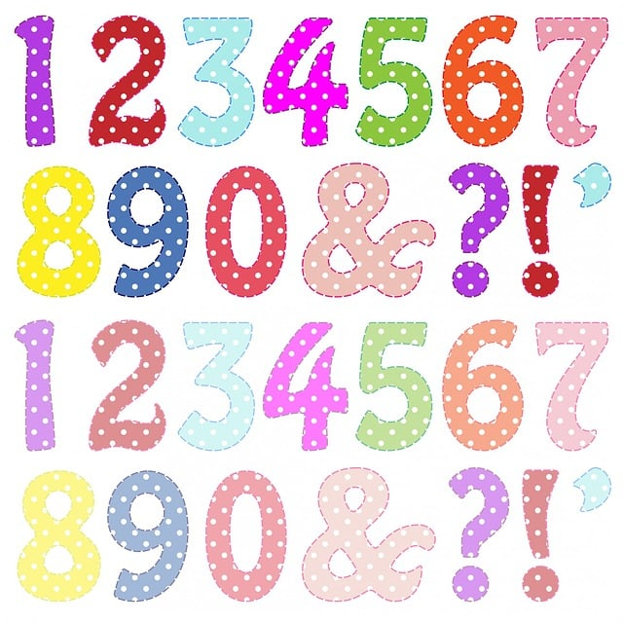Ein Bild, das Kinderkunst, Design enthält.
Ein Bild, das Kinderkunst, Design enthält.
Ein Bild, das Kinderkunst, Design enthält.
Ein Bild, das Kinderkunst, Design enthält.
Ein Bild, das Kinderkunst, Design enthält.
Ein Bild, das Kinderkunst, Design enthält.

|  |  |  |
| --- | --- | --- |
| 1 x 2 | = | 2 |
| 2 x 2 | = | 4 |
| 3 x 2 | = | 6 |
| 4 x 2 | = | 8 |
| 5 x 2 | = | 10 |
| 6 x 2 | = | 12 |
| 7 x 2 | = | 14 |
| 8 x 2 | = | 16 |
| 9 x 2 | = | 18 |
| 10 x 2 | = | 20 |

|  |  |  |
| --- | --- | --- |
| 1 x 3 | = | 3 |
| 2 x 3 | = | 6 |
| 3 x 3 | = | 9 |
| 4 x 3 | = | 12 |
| 5 x 3 | = | 15 |
| 6 x 3 | = | 18 |
| 7 x 3 | = | 21 |
| 8 x 3 | = | 24 |
| 9 x 3 | = | 27 |
| 10 x 3 | = | 30 |

|  |  |  |
| --- | --- | --- |
| 1 x 1 | = | 1 |
| 2 x 1 | = | 2 |
| 3 x 1 | = | 3 |
| 4 x 1 | = | 4 |
| 5 x 1 | = | 5 |
| 6 x 1 | = | 6 |
| 7 x 1 | = | 7 |
| 8 x 1 | = | 8 |
| 9 x 1 | = | 9 |
| 10 x 1 | = | 10 |

|  |  |  |
| --- | --- | --- |
| 1 x 9 | = | 9 |
| 2 x 9 | = | 18 |
| 3 x 9 | = | 27 |
| 4 x 9 | = | 36 |
| 5 x 9 | = | 45 |
| 6 x 9 | = | 54 |
| 7 x 9 | = | 63 |
| 8 x 9 | = | 72 |
| 9 x 9 | = | 81 |
| 10 x 9 | = | 90 |

|  |  |  |
| --- | --- | --- |
| 1 x 8 | = | 8 |
| 2 x 8 | = | 16 |
| 3 x 8 | = | 24 |
| 4 x 8 | = | 32 |
| 5 x 8 | = | 40 |
| 6 x 8 | = | 48 |
| 7 x 8 | = | 56 |
| 8 x 8 | = | 64 |
| 9 x 8 | = | 72 |
| 10 x 8 | = | 80 |

|  |  |  |
| --- | --- | --- |
| 1 x 7 | = | 7 |
| 2 x 7 | = | 14 |
| 3 x 7 | = | 21 |
| 4 x 7 | = | 28 |
| 5 x 7 | = | 35 |
| 6 x 7 | = | 42 |
| 7 x 7 | = | 49 |
| 8 x 7 | = | 56 |
| 9 x 7 | = | 63 |
| 10 x 7 | = | 70 |

|  |  |  |
| --- | --- | --- |
| 1 x 6 | = | 6 |
| 2 x 6 | = | 12 |
| 3 x 6 | = | 18 |
| 4 x 6 | = | 24 |
| 5 x 6 | = | 30 |
| 6 x 6 | = | 36 |
| 7 x 6 | = | 42 |
| 8 x 6 | = | 48 |
| 9 x 6 | = | 54 |
| 10 x 6 | = | 60 |

|  |  |  |
| --- | --- | --- |
| 1 x 5 | = | 5 |
| 2 x 5 | = | 10 |
| 3 x 5 | = | 15 |
| 4 x 5 | = | 20 |
| 5 x 5 | = | 25 |
| 6 x 5 | = | 30 |
| 7 x 5 | = | 35 |
| 8 x 5 | = | 40 |
| 9 x 5 | = | 45 |
| 10 x 5 | = | 50 |

|  |  |  |
| --- | --- | --- |
| 1 x 4 | = | 4 |
| 2 x 4 | = | 8 |
| 3 x 4 | = | 12 |
| 4 x 4 | = | 16 |
| 5 x 4 | = | 20 |
| 6 x 4 | = | 24 |
| 7 x 4 | = | 28 |
| 8 x 4 | = | 32 |
| 9 x 4 | = | 36 |
| 10 x 4 | = | 40 |