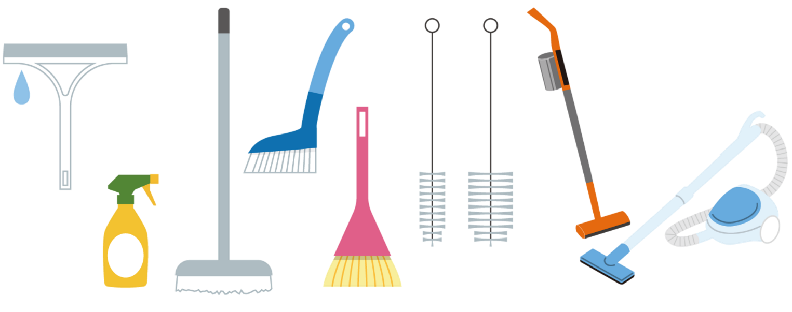

UNSER

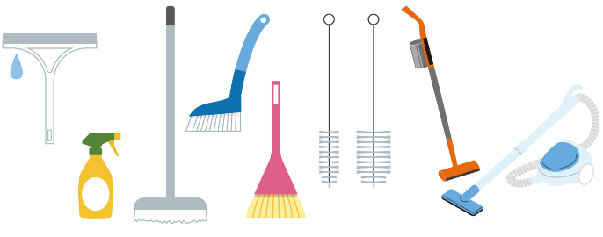

**HAUSHALTSPLAN**

|  |  |  |  |  |
| --- | --- | --- | --- | --- |
| täglich | wöchentlich | 14 tägig | monatlich | seltener |
|  |  |  |  |  |
|  |  |  |  |  |
|  |  |  |  |  |
|  |  |  |  |  |
|  |  |  |  |  |
|  |  |  |  |  |
|  |  |  |  |  |
|  |  |  |  |  |
|  |  |  |  |  |
|  |  |  |  |  |
|  |  |  |  |  |
|  |  |  |  |  |

|  |
| --- |
| erledigt |
|  |
|  |
|  |
|  |
|  |
|  |
|  |
|  |
|  |
|  |
|  |
|  |



|  |
| --- |
| NAME |
| Jan |
| Eric |
| Miriam |
| Julia |
|  |
|  |
|  |
|  |
|  |
|  |
|  |

|  |  |  |  |  |  |  |
| --- | --- | --- | --- | --- | --- | --- |
| Mo | Di | Mi | Do | Fr | Sa | So |
|  |  |  |  |  |  |  |
|  |  |  |  |  |  |  |
|  |  |  |  |  |  |  |
|  |  |  |  |  |  |  |
|  |  |  |  |  |  |  |
|  |  |  |  |  |  |  |
|  |  |  |  |  |  |  |
|  |  |  |  |  |  |  |
|  |  |  |  |  |  |  |
|  |  |  |  |  |  |  |
|  |  |  |  |  |  |  |
|  |  |  |  |  |  |  |

|  |
| --- |
| AUFGABEN |
| Müll rausbringen |
| Kinderzimmer aufräumen |
| Bad putzen |
| Kochen |
|  |
|  |
|  |
|  |
|  |
|  |
|  |
|  |

