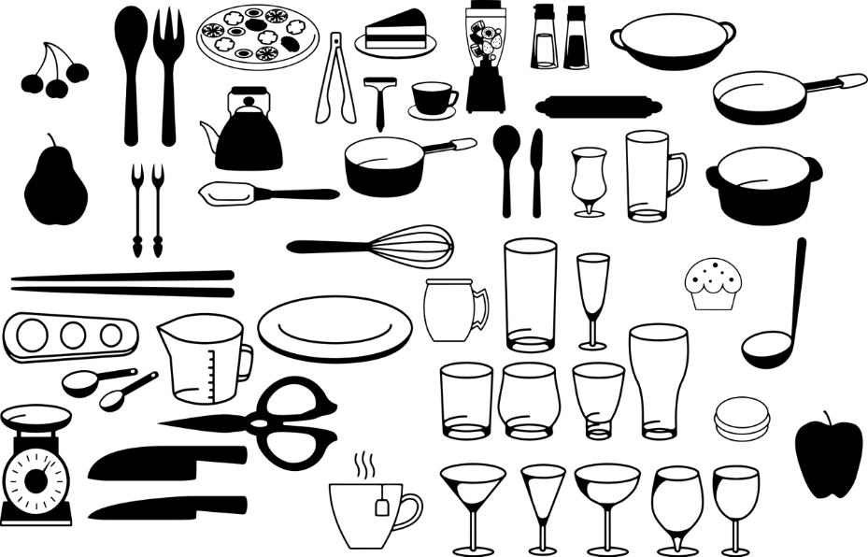

Tagesplaner

**NOTIZEN**

|  |
| --- |
|  |
|  |
|  |
|  |
|  |
|  |
|  |
|  |

Trinkpäuschen

**TO DO**

|  |  |
| --- | --- |
|  |  |
|  |  |
|  |  |
|  |  |
|  |  |
|  |  |
|  |  |
|  |  |
|  |  |

SO

SA

FR

DO

MI

DI

MO

**TERMINE**

|  |
| --- |
|  |
|  |
|  |
|  |