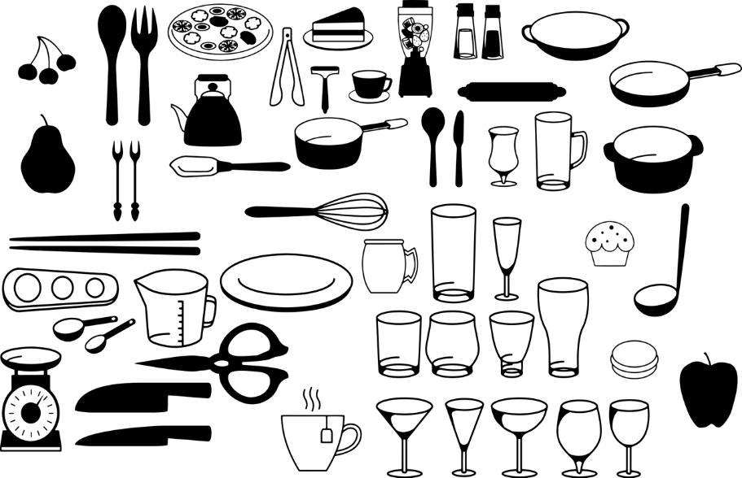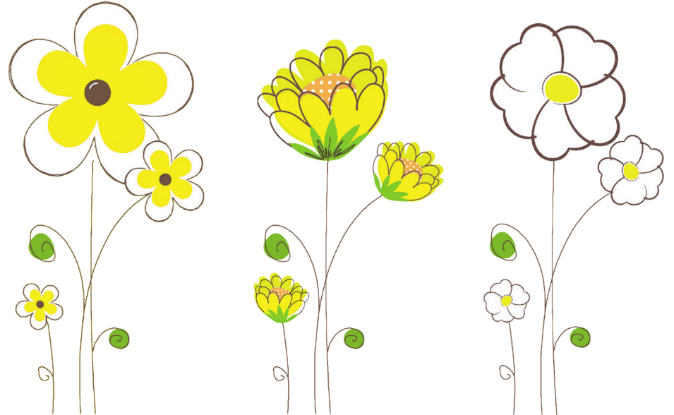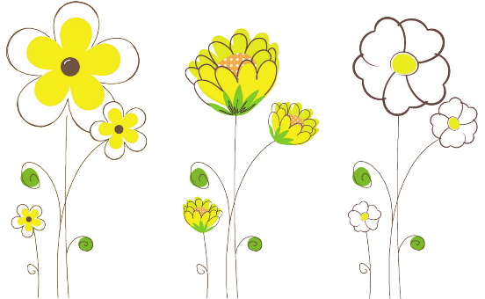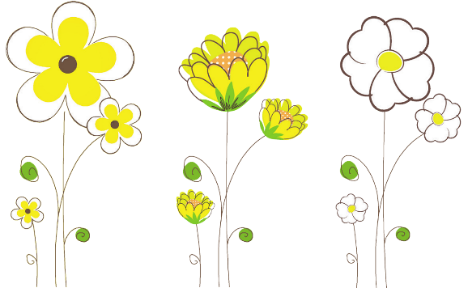

**MO**

**DI**

**MI**

**DO**

**FR**

**SA**

**SO**

Mein wunderbarer Tag!

NOTIZEN

|  |  |  |  |  |  |  |  |  |  |  |  |  |  |  |  |  |
| --- | --- | --- | --- | --- | --- | --- | --- | --- | --- | --- | --- | --- | --- | --- | --- | --- |
|  |  |  |  |  |  |  |  |  |  |  |  |  |  |  |  |  |
|  |  |  |  |  |  |  |  |  |  |  |  |  |  |  |  |  |
|  |  |  |  |  |  |  |  |  |  |  |  |  |  |  |  |  |
|  |  |  |  |  |  |  |  |  |  |  |  |  |  |  |  |  |
|  |  |  |  |  |  |  |  |  |  |  |  |  |  |  |  |  |
|  |  |  |  |  |  |  |  |  |  |  |  |  |  |  |  |  |
|  |  |  |  |  |  |  |  |  |  |  |  |  |  |  |  |  |
|  |  |  |  |  |  |  |  |  |  |  |  |  |  |  |  |  |
|  |  |  |  |  |  |  |  |  |  |  |  |  |  |  |  |  |
|  |  |  |  |  |  |  |  |  |  |  |  |  |  |  |  |  |
|  |  |  |  |  |  |  |  |  |  |  |  |  |  |  |  |  |
|  |  |  |  |  |  |  |  |  |  |  |  |  |  |  |  |  |
|  |  |  |  |  |  |  |  |  |  |  |  |  |  |  |  |  |
|  |  |  |  |  |  |  |  |  |  |  |  |  |  |  |  |  |

TERMINE & VERABREDUNGEN

MEINE TO DO´S

|  |  |
| --- | --- |
|  |  |
|  |  |
|  |  |
|  |  |
|  |  |
|  |  |
|  |  |
|  |  |
|  |  |

MEINE PRIORITÄTEN FÜR HEUTE

|  |  |
| --- | --- |
|  |  |
|  |  |
|  |  |