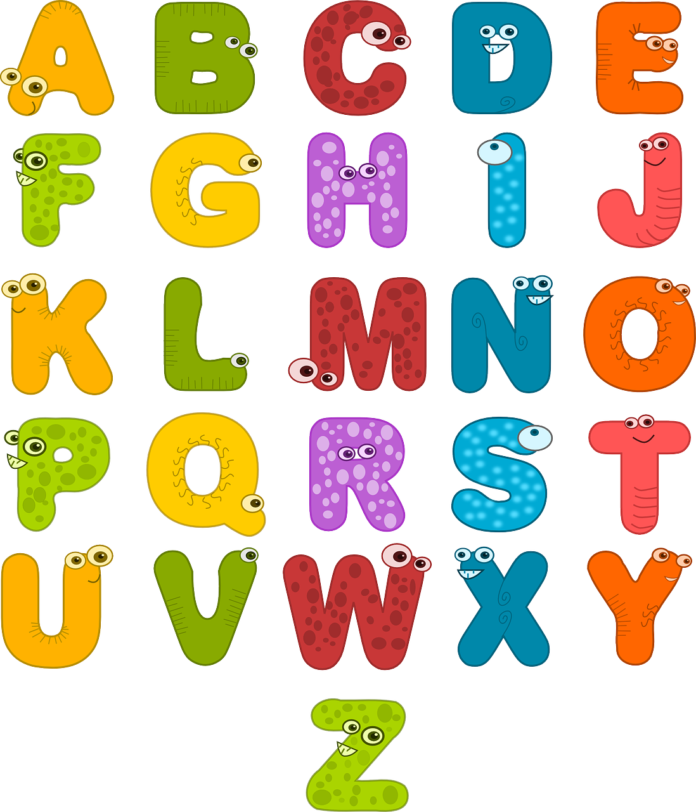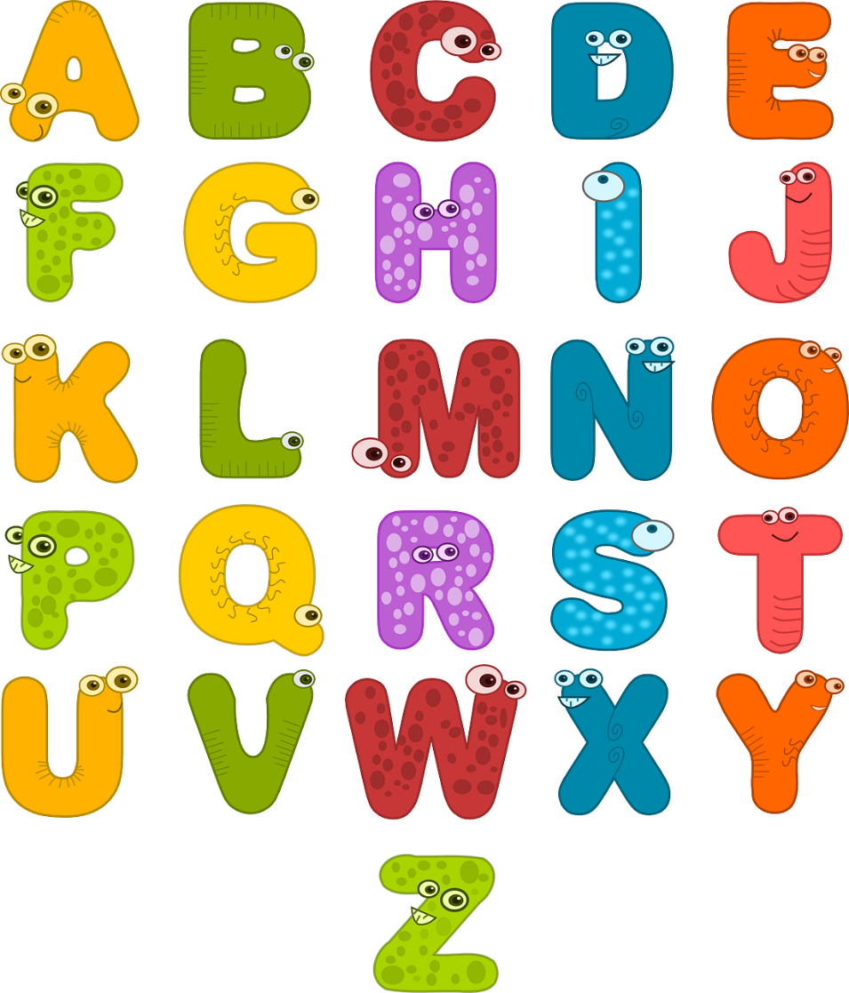

|  |  |  |  |  |  |  |
| --- | --- | --- | --- | --- | --- | --- |
| Std. | Zeit | Montag | Dienstag | Mittwoch | Donnerstag | Freitag |
|  |  |  |  |  |  |  |
|  |  |  |  |  |  |  |
|  |  |  |  |  |  |  |
|  |  |  |  |  |  |  |
|  |  |  |  |  |  |  |
|  |  |  |  |  |  |  |
|  |  |  |  |  |  |  |

STUNDENPLAN