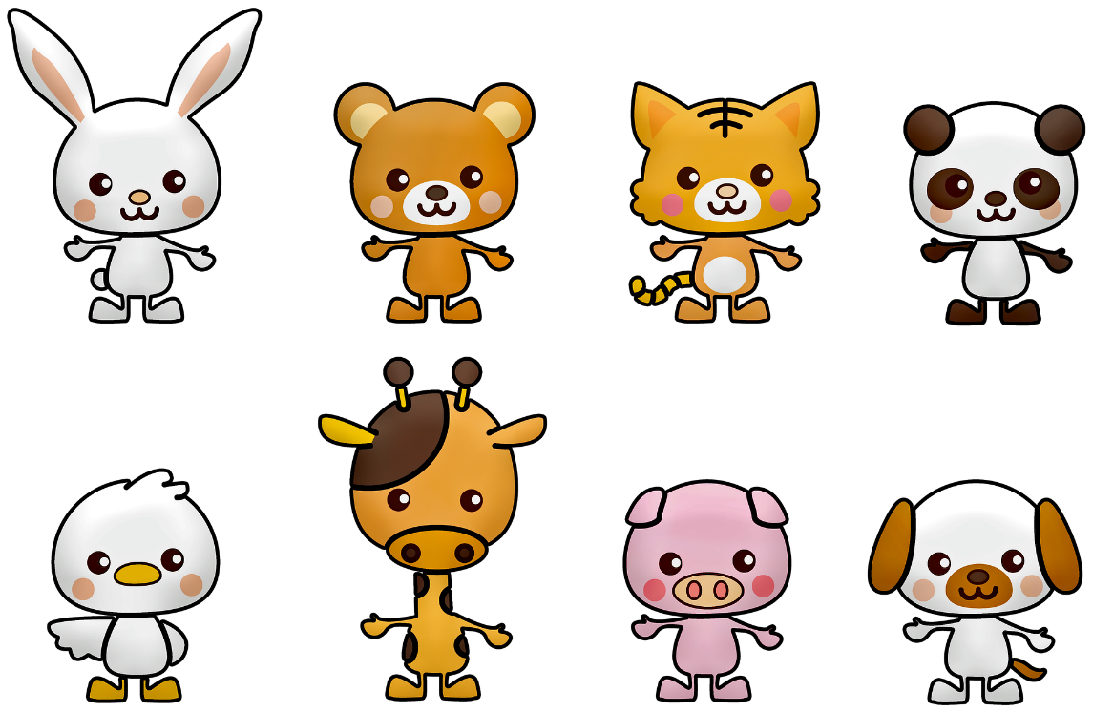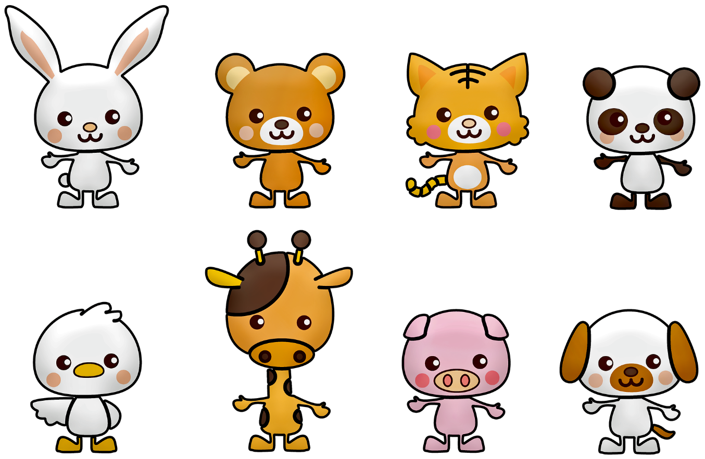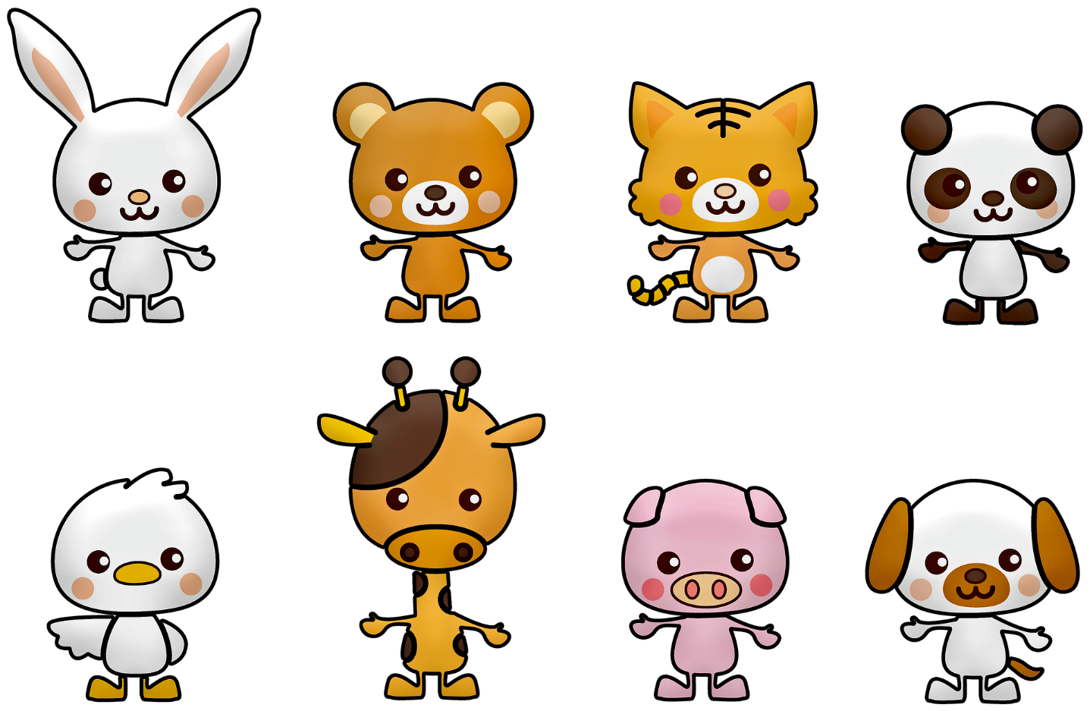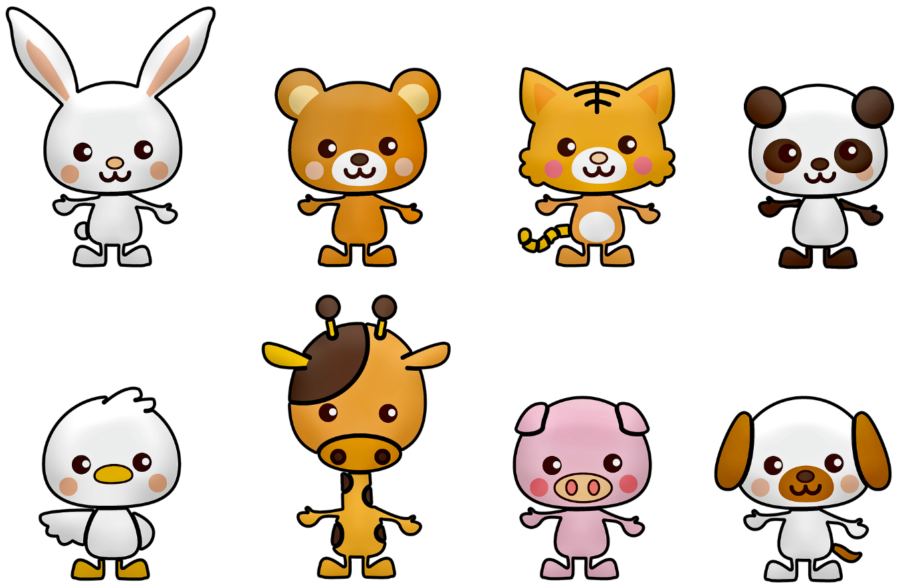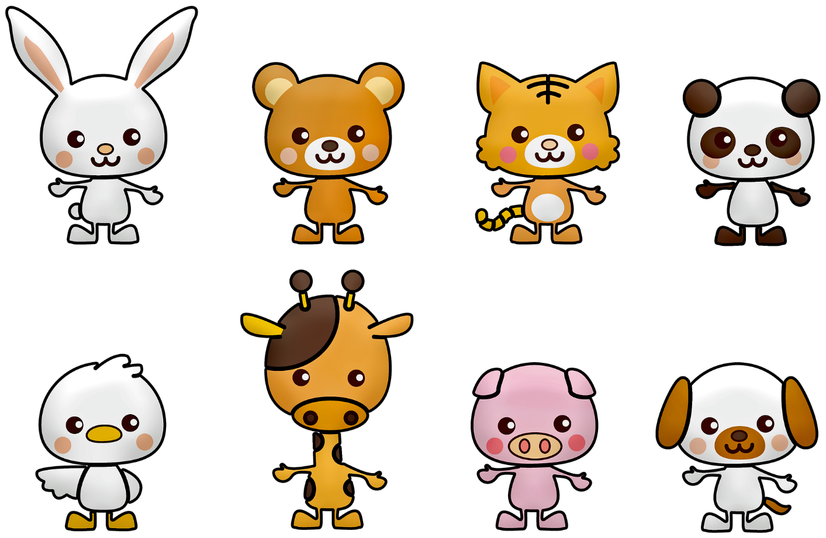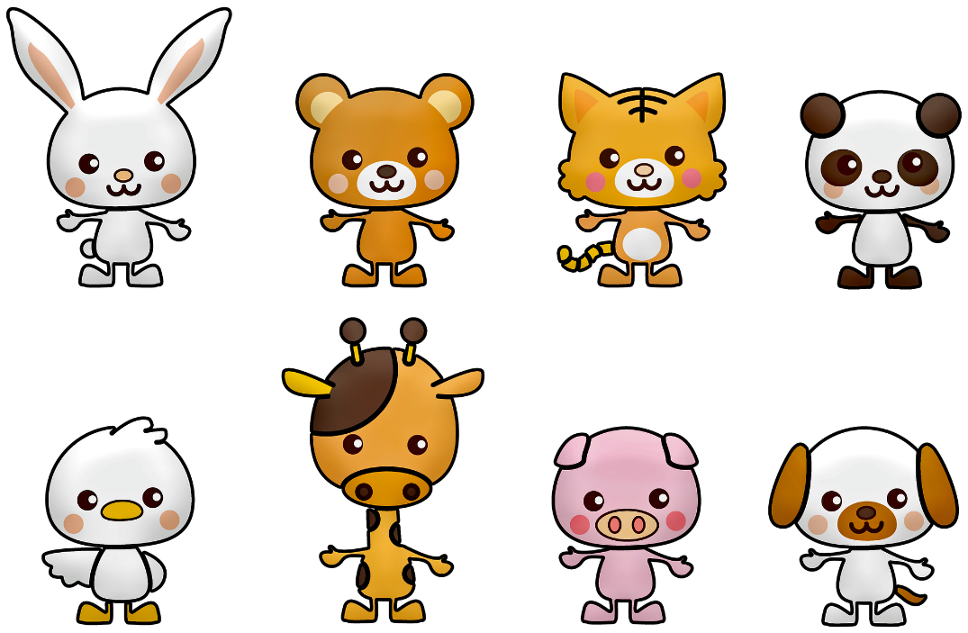

|  |
| --- |
|  |
|  |
|  |
|  |
|  |
|  |
|  |
|  |

|  |
| --- |
|  |
|  |
|  |
|  |
|  |
|  |
|  |
|  |

|  |
| --- |
|  |
|  |
|  |
|  |
|  |
|  |
|  |
|  |

|  |
| --- |
|  |
|  |
|  |
|  |
|  |
|  |
|  |
|  |

|  |
| --- |
|  |
|  |
|  |
|  |
|  |
|  |
|  |
|  |

|  |
| --- |
|  |
|  |
|  |
|  |
|  |
|  |
|  |
|  |

Donnerstag

Freitag

Mittwoch

Montag

Dienstag

Zeit

STUNDENPLAN