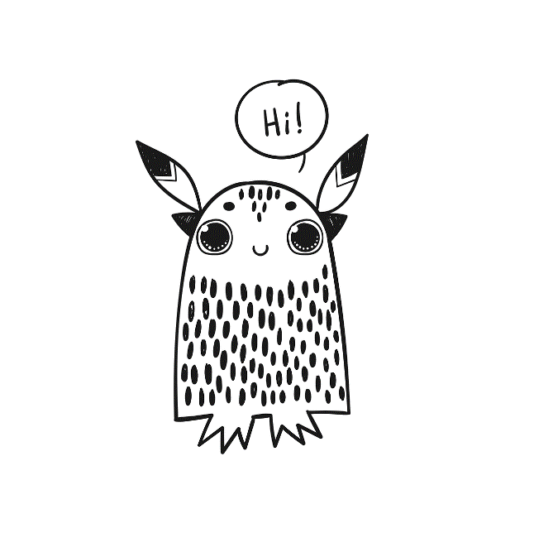

**Let´s**

**do this !**

|  |  |
| --- | --- |
|  |  |
|  |  |
|  |  |
|  |  |
|  |  |
|  |  |
|  |  |
|  |  |
|  |  |
|  |  |
|  |  |
|  |  |
|  |  |
|  |  |
|  |  |